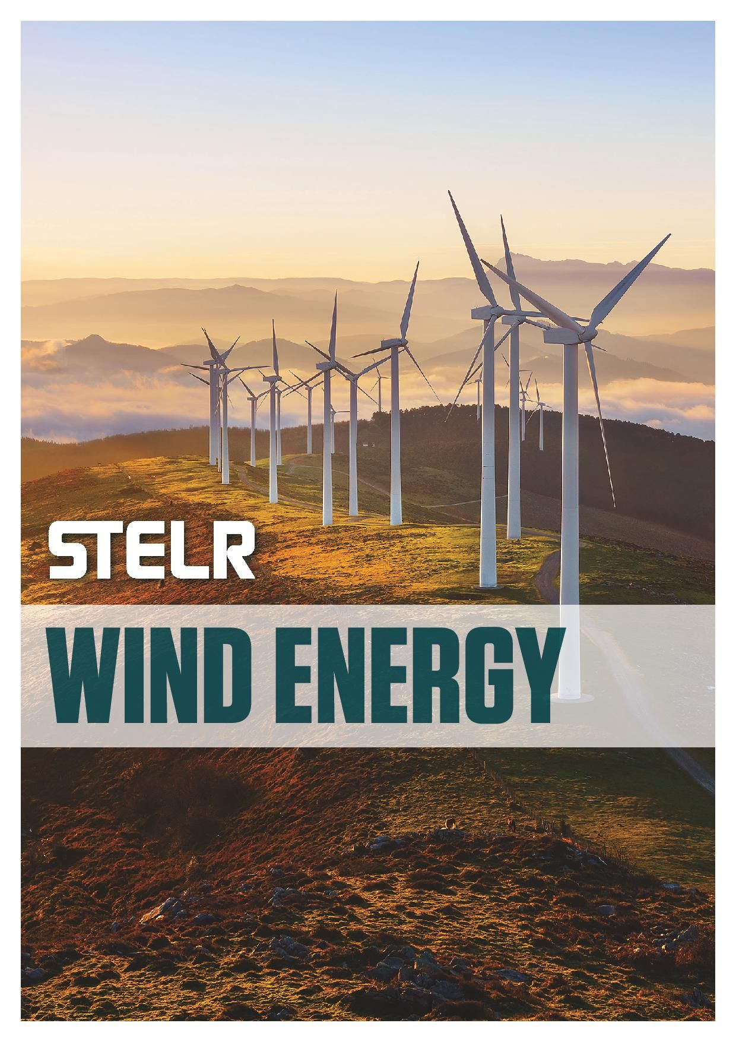

TABLE OF CONTENTS

STELR Wind Energy Kits 3

STELR Wind Energy Web page 4

STELR Wind Energy Curriculum Links 4

Information about Wind Turbines and Wind Farms 5

How do wind turbines work? 6

Where is the best place to locate a wind farm? 8

The energy efficiency of wind turbines 10

Advantages of wind turbines 11

Disadvantages of wind turbines 12

Issues about wind turbines 12

Wind Turbine Investigations 14

General information for practical activities 14

Notes on Each Prac 19

Wind Farm Issues 24

Wind Turbines and Birds 24

Wind Turbine Syndrome 26

How Scientists Work 26

Optional Investigations 27

Trying other variables 27

Making the most cost effective wind turbine 27

Build your own wind turbine blades. 27

Wind blade specifications 28

Appendices 30

Wind Energy Module Pre- and Post-test 30

Post-test answers. 34

Rubrics 36

Investigation Planner 42

STELR Wind Energy teacher resource

# STELR Wind Energy Kits

The practical activities in this resource are based around the use of the STELR Wind Energy Kit. The STELR Wind Energy kit contains:

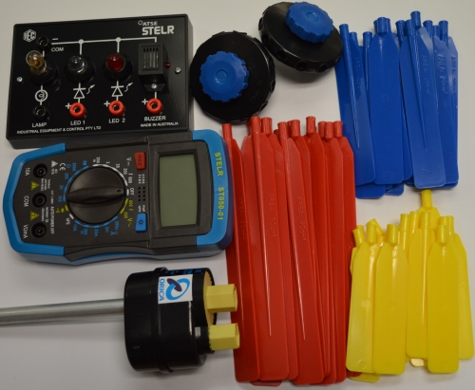

|  |  |
| --- | --- |
| **Contents of one STELR Wind Energy Student Kit** | |
| Mini test rig module | 1 |
| Multimeter | 1 |
| Wind turbine generator | 1 |
| Clamping hub for wind turbine blades | 2 |
| 150 mm long blade | 1 set (of 15) |
| 100 mm medium blade | 1 set (of 15) |
| 75 mm short blade | 1 set (of 15) |
| Cable (red, black in sleeve) | 1 |

In addition, you will require at least one high velocity fan as your ‘wind’ source.  
Specific instructions about how to use and maintain the equipment items can be found on the STELR website.

Additional Wind Energy Kits can be purchased individually or in class sets from STELR.  
Contact: Ph 03 9864 0900 [STELR.admin@atse.org.au](mailto:STELR.admin@atse.org.au)

Spare parts can be purchased from the STELR equipment supplier, IEC.  
Contact: Ph 03 9497-2555 [iec@iecpl.com.au](mailto:iec@iecpl.com.au)

***Wind Energy*** was written and produced by the STELR project team.

Science and Technology Education Leveraging Relevance (STELR) is the key school education initiative of the Australian Academy of Technology and Engineering. [www.atse.org.au](http://www.atse.org.au)

# STELR Wind Energy Web page

The STELR Wind Energy Web page is at <https://stelr.org.au/stelr-modules/wind-energy/>

On this page you will find:

* Downloadable curriculum materials
* Links to the STELR Global Warming video *Cold Facts, Hot Science*
* Information about the equipment kits and how to order them including part codes
* Information on how to use and maintain the STELR equipment
* Additional information and resources including:
  + Curriculum Links
  + Wind Energy Theory
  + Information about climate change
  + Career profiles of people working in the field.

In particular the Additional resources section <https://stelr.org.au/additional-info/wind-energy/>  
includes:

* A podcast about wind energy
* Interactive Wind resource map
* A case study of the Snowtown Wind Farm
* Information about 3D printing your own wind vanes
* A revision PowerPoint presentation

# STELR Wind Energy Curriculum Links

This unit covers energy resources, energy transfers and transformations and electric circuits. It links to the Australian Curriculum Science in Years 6, 7 and 8. The activities are designed as inquiry questions and are deigned to teach students science inquiry skills. Science as a human endeavour is explored through the career profiles.

For a full list of the Science curriculum links go to <https://stelr.org.au/stelr-modules/wind-energy/wind-energy-curriculum-links/>

Maths activities are also embedded throughout the module.

# Information about Wind Turbines and Wind Farms

A **wind turbine** is rather like a giant fan in reverse. When the wind sets it spinning, it generates electricity. Wind turbines can range in size from small ones installed on large yachts and small buildings, to giant ones on wind farms.

A **wind farm** is a set of wind turbines that are linked together to supply electricity to a local community or to an electricity grid for a larger population. Many are located along coastlines where the winds are stronger.

An example of this is Woolnorth wind farm in Tasmania, shown in Figures 1 and 2.

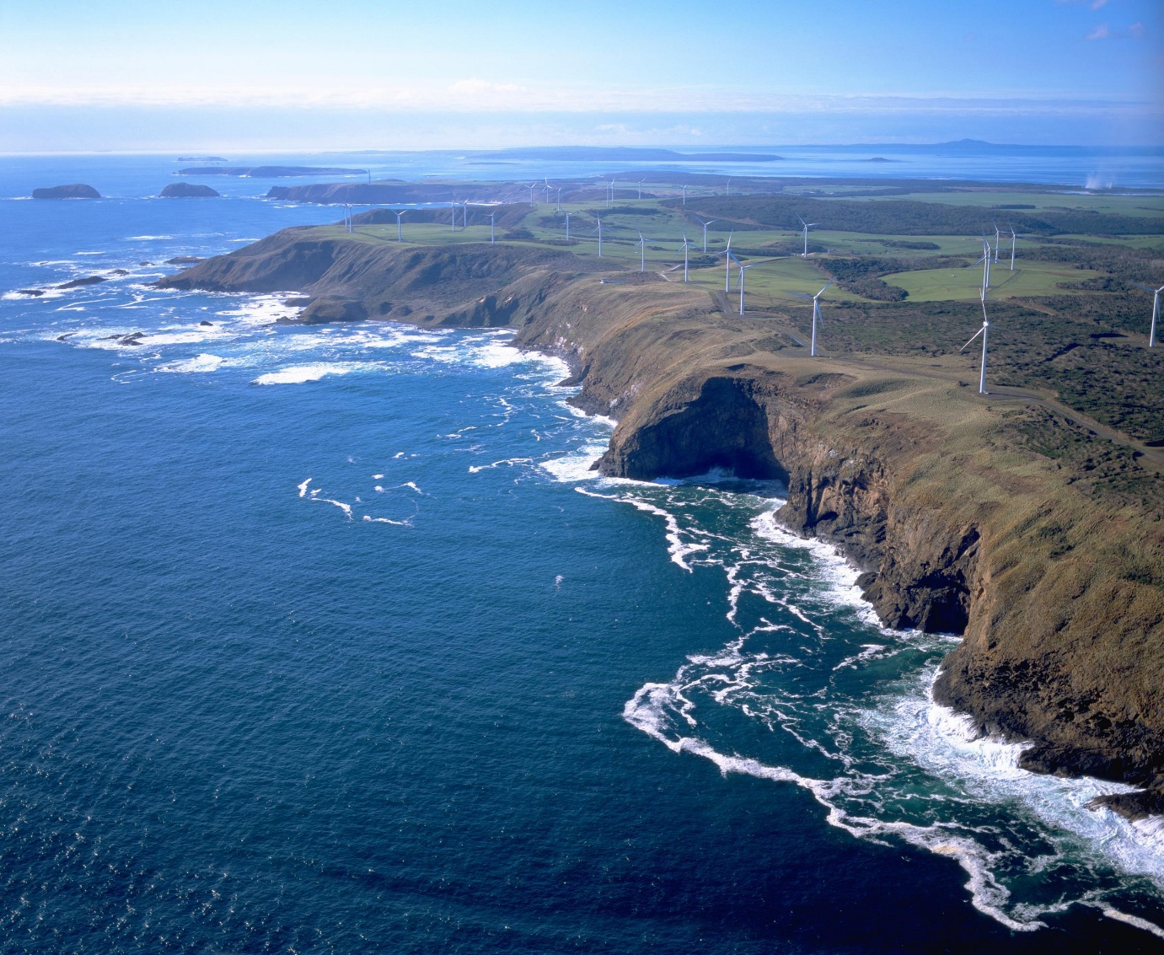

Figure 1. A coastal view of the 140 MW Woolnorth Wind Farm, located on the far north-west coast of Tasmania where the Great Southern Ocean meets Bass Strait. Up until April 2008, this was the biggest wind farm operating in the southern hemisphere.

PHOTO CREDIT: Hydro Tasmania

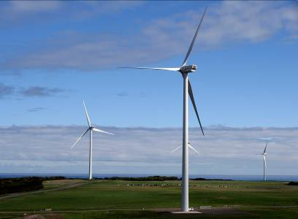

Figure 2. A close-up view of wind turbines at Studland Bay Wind Farm. The van at the base of one of the towers, and the cattle in the background, give some idea of their size.

PHOTO CREDIT: Hydro Tasmania

## How do wind turbines work?

**Wind turbines** transform the kinetic energy of the wind into electrical energy.

Figure 3 shows the key energy transformations that take place.

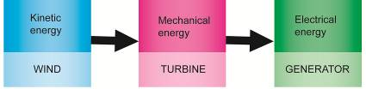

Figure 3. The main energy transformations that take place in a wind turbine.

The main steps are:

**STEP 1:** Moving air pushes against the blades of the turbine, which are tilted to the direction of the wind. This makes the blades spin. In the process, some of the kinetic energy of the moving air is transformed into the mechanical energy of the spinning blades. (The wind still has some kinetic energy as it flows away from the turbine.)

**STEP 2:** The shafts and the gears inside the gear box transfer the mechanical energy of the turbine to the generator. (The gears make the drive shaft to the generator spin faster than the shaft connected to the blade hub.)

**STEP 3:**The generator transforms mechanical energy into electrical energy.

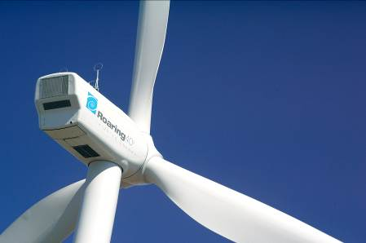

Figure 4. A close-up view of a wind turbine at the Woolnorth wind farm.

PHOTO CREDIT: Hydro Tasmania.

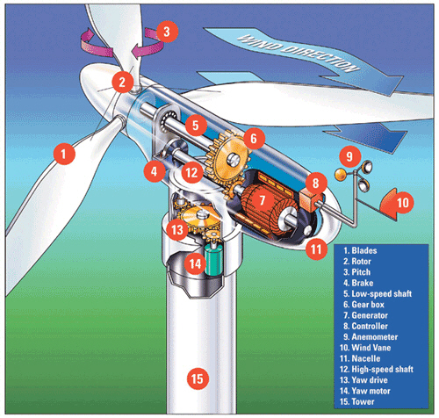

Figure 5. A wind turbine – an inside view.

**Source:** <http://www.alliantenergykids.com/wcm/groups/wcm_internet/@int/@aekids/documents/image/022691.jpg>

**Accessed:** 4 January, 2011

## Where is the best place to locate a wind farm?

Wind turbines must, of course, be located where there are steady strong winds - though not so strong that they would damage the turbines.

Wind turbines work most effectively when they operate in ‘smooth air’ (when the air particles are moving parallel to one another). If, say, 10% of air is travelling against the main direction of air motion, it will reduce the efficiency of the turbine by 20%, since it is cancelling out the energy of another 10% of the air movement.

Ideal sites for wind turbines therefore must be:

* Away from obstructions that may cause turbulence, such as rocky outcrops, towers and forests
* At the highest point possible
* Clear space of approximately 10 times the height of local obstacles such as nearby buildings, hills or trees

The best place is on top of a smooth hilltop, where the wind increases in speed, and turbulence is at a minimum.

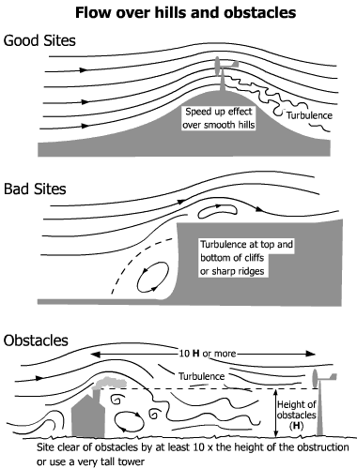

Figure 6.How the air moves over hills and obstacles**.**

**Source:** <http://www.bwea.com/you/siting.html> **Accessed:** 21-01-2010

### Factors which determine how much power is generated by a wind turbine

As we may expect, the major factor determining power generated is wind speed.

**The power of the wind is proportional to the cube of the wind speed.**

This means that:

* If the wind speed were 2 times greater, the power available would be 8 times greater.
* If the wind speed were 3 times greater, the power available would be 27 times greater.
* If the wind speed were 10 times greater, the power available would be 1000 times greater.

However,it must be realised thatwind turbines do not produce electricity all the time. Although the wind might be available for as much as 70 % of the time, it is often not strong enough to operate the wind turbine at full capacity. The combination of absence of wind and inadequate wind strength means that even in a good location the wind turbine, over the course of a year, will generate only about 30 % of the amount it could generate in a constant strong wind.

The amount of electrical power produced by a wind turbine doesn’t only depend on the speed of the wind, and how smoothly it flows, however. It also depends on the way the turbine is built:

The number of blades

* The length of the blades
* The shape of the blades
* The weight of the blades
* The pitch (angle) of the blades to the wind
* The height of the tower
* The gears used
* The type of generator used
* The computer system that controls the operation of the turbine and its power output (where this is used)

## The energy efficiency of wind turbines

A good site might have a 35 % **capacity factor (Cp=0.35)**. This means that the turbines will produce 35% of their capacity on average over a year

Apart from problems with the wind itself, some of the kinetic energy of the wind is ‘wasted’, due to the fact some is transformed into heat energy (the gears and shafts get hot) and sound energy ( the blades, gears and shafts make some noise as they spin.

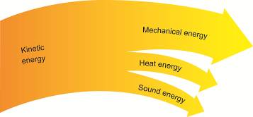

Figure 7. A Sankey diagram showing how some of the kinetic energy of the wind is transformed into a useful form of energy (mechanical energy) and some is transformed into forms of energy that are not useful (heat energy and sound energy).

## Advantages of wind turbines

The main advantages of wind turbines, once they are built*, are:

1 They are a **renewable** energy resource – there always will be wind!

2 They do not emit greenhouse gases or any other pollution.

3 They are more energy-efficient than most power stations that burn fossil fuels.

4 They are less costly to run than many other energy resources.

5 They can be established in remote areas where other energy resources are not practical, even in places like Antarctica and on ocean-going yachts.

*Greenhouse gases and other pollutants are produced during the manufacture, transport and installation of wind turbines, but once they have operated for a year or so, they will have compensated for this. Overall, wind turbines help reduce the amount of greenhouse gases emitted into the atmosphere.

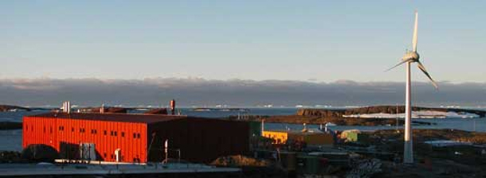

Figure 8. A wind-diesel energy resource that was built by Australian scientist Dr Alan Langworthy and his company, Powercorp Pty. Ltd., at the Mawson base in Antarctica. Alan also has built wind turbines at the Murdoch and Scott bases. PHOTO CREDIT: Powercorp Pty. Ltd

## Disadvantages of wind turbines

Some of the disadvantages of wind turbines are:

**•** The electrical power delivered by wind turbines varies because both wind speed and direction vary. Sometimes the wind speed is too low to even start rotation. Therefore they can only be used to provide some of the electrical power people need.

**•** They can be damaged byvery strong winds and also corroded by salt in the air when located near the sea.

**•** It can be costly to connect them to the electricity grid, due to the long distances involved.

**•** Some people think they spoil the landscape due to visual impact, which could have a negative effect on the local tourist industry.

**•** They need to have flashing lights on the top to warn the pilots of any aircraft that fly overhead of their presence. Some people who live close by claim that the flashing lights disturb their sleep.

**•** In many countries, most of their wind turbines are located offshore, usually because people do not want them across the land. This is a much more expensive location, because the turbines are more costly to install and to maintain, because of problems such as corrosion of metal parts by sea water and damage from the constant movement of waves and sand. This means the electricity they generate is more expensive than that generated by coal-fired power stations.

**•** There will be some impact on local bird populations and other species, such as bats.

## Issues about wind turbines

**The noise issue**

Some people believe the sound produced by wind turbines is annoying or even harmful.

However, tests conducted by Danish sound engineers on many wind turbines in Denmark have shown that the loudness of sound heard in any location depends on wind direction and speed. The engineers reported that they often could not detect any sound above normal natural levels in areas near wind turbines. Even when they could, the loudness of the sound was not of a level that would harm people’s hearing.

They also found that no infrasound was produced by the wind turbines they tested. Infrasound is low frequency sound that cannot be detected by the human ear. Infrasound is thought to cause a number of health problems.

**What say do local communities have?**

Many local communities, or the majority of members of local communities, are very happy to have a wind farm installed near them. Usually farming communities, they benefit from the jobs such developments bring into their area.

Moreover, wind turbines are often installed on farms and provide the farmers with extra income. Cattle and sheep still graze peacefully under them.

However, Aboriginal sacred sites in the region must be respected and disturbance avoided.

**Animation of how wind turbines work**

This animation on how wind turbines work is provided by the US Department of Energy:

<http://www1.eere.energy.gov/wind/wind_animation.html>

Further information on wind turbines can be found at the STELR website. [www.stelr.org](http://www.stelr.org)

# Wind Turbine Investigations

## General information for practical activities

### Advice for the classroom

Working in small groups of two or three gives students a greater opportunity to be actively engaged instead of merely being spectators in the activity. As a result, they are more likely to develop the skills and understandings that will help them in later investigations.

Trial the activity prior to the class, to identify problems the students might encounter, to judge the time they need and to decide how to best manage the activity, particularly who should be in each group.

### Setting up

Always remove the hub from the turbine before changing blades.

To insert the blades into a hub, loosen the tensioning knob on the hub that holds them firmly in place. Insert the blades carefully at the correct angle. Press each blade into its hole as far as it can go, so its base is right against the hub. This may or may not produce a clicking sound. Then rotate it so that it is at an angle of 45⁰ and its smooth side is facing the tensioning knob. Ensure that the blades are evenly spaced. Once all the blades are inserted, tighten the knob again. Note that if the blades are not fully inserted, the blades will be loose, even if the tensioning screw is screwed up as tightly as possible. Ensure blades are tight to improve experimental results and to avoid injuries.

The hub to fan distance should be about 50 cm.

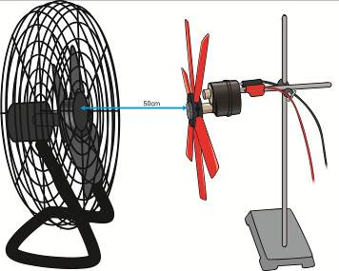

The positioning of blades assumes regular spacing. A side question easily dealt with is about the need for balance on the hub. What happens if the hub is ‘unbalanced’ or ‘unsupported’

The hub is unbalanced when the blades are unevenly distributed around the hub.

The hub is unsupported when the wind turbine assembly is mounted on a stand which moves or sways. Notice the increase/decrease in voltage output if the stand is prevented from moving. Ie. clamped to a rigid stand.

### Running the experiments

1. The rotational speed of the turbine varies over time; a steady reading is therefore not possible. It is best to let the turbine reach as steady a speed as possible, then quickly take the readings.
2. It can be useful to place masking tape on the bench to mark the positions of the fan and turbine, so that they can be kept at a constant distance apart.
3. Ensure that the turbines do not vibrate excessively, as this may reduce their efficiency. If one does vibrate excessively, first check that all the blades were properly inserted into the hub. If they were inserted correctly, the vibration may be caused by the fact that the blades are not identical and are not completely balanced. These vibrations can be reduced by adding small amounts of Blu-Tac to balance the turbine (like in a car wheel balance).

### Safety

All apparatus requires checking for safe operation, in every activity with the mains powered fan students are encouraged to perform a safety check before switching on power AND seeking teacher approval.

The electric fan wind source should be regularly inspected for a secure fan guard, and students need to be encouraged to be observant and report any potential dangers.

Clamps to secure spinning apparatus to the bench are advised at all times.

There is a small chance that the blades could fly out of the hub if they are not inserted properly. Students should wear safety glasses as a protection.

While voltages and currents generated are relatively small, standard electricity safety procedures need to be followed, these include isolation away from water, short connector wires, restricted opportunity for overheating by limiting the length of time the circuits are active.

### Risk management

Students should be actively supervised throughout this practical activity.

Possible responses to the students’ risk assessment activity are shown below.

**Student activity sheet**

|  |  |  |
| --- | --- | --- |
| **The facts** | **What might be the risks?** | **What precautions will we take?** |
| 1 The model wind turbines could break if mishandled. | The model wind turbine could be accidentally dropped or set up wrongly. | Keep the equipment well away from the edge of the bench and do not lean on or over benches or move books or bags near them.  Do not haveother equipment nearby.  Have the teacher check the set-up and the circuit before turning on the three-speed fan. |
| 2 Inserting the blades into the hub of the model wind turbine, or pulling them out, can cause breakages as well as hand injuries. | If this is not done according to the instructions, the equipment may break and people may cut their hand. | Follow the step-by-step instructions carefully. Do not try to do this too quickly. If necessary, ask the teacher to demonstrate this again. |
| 3 If the blades are not inserted firmly into the hubs, they may fly out at a high speed whilst the turbine is spinning, and cause eye injuries. | If the hubs are not properly inserted and carefully tested before starting them spinning, someone could get a serious eye injury. | Have the teacher check that the blades are set into the hub correctly before placing it on the shaft of the wind turbine, then again after it is on the shaft. If there still is concern, wear safety glasses. |
| 4 A fast-spinning electric fan will be used in this experiment. | Fingers or long hair could be caught in the fan, causing someone serious injury.  Since the fan is an electrical device connected to mains electricity, someone could get electrocuted if there is water around or the lead gets pulled. | Tie back long hair and keep well away from the fan.  Only use a fan that has a protective cage around it.  Be very careful with the lead to the fan. Do not have water nearby. |

### 

### Introducing the activity:

* Introduce this practical activity by outlining the inquiry question and telling the students they are to design their own experiment to discover the answer.
* Assign the students to their groups and give them an investigation planner. They should complete the first page of this.
* State your expectations of their behaviour and the time limits they will work under.

### During the activity:

* Ensure that the students **do not start the experiment until they have submitted their investigation planner and had it approved.**
* Be vigilant. Check that the students are setting up the equipment correctly
* With each group, whilst checking their equipment and circuit, ask the students questions about whether they are having any problems with the design of the experiment and what modifications they have made (if any), what they are discovering and what explanations they can suggest. Check that they are only changing one variable at a time.
* Check that the students observe all of the agreed-upon procedures and safety precautions and are obtaining results in a timely manner.

### At the end of each activity:

Draw the students together to report their findings. They should discuss which, if any, of their predictions came true, any problems they encountered, their conclusions and suggested explanations for their results. Ensure that each group contributes to the discussion.

This part of the session is very important because it will help the students clarify ideas and develop communication skills.

### List of materials required for each session (Per student pair)

* STELR testing station
* STELR model wind turbine
* STELR multimeter
* Connecting leads (with ‘piggy-back’ banana plugs)
* 6 x 150 mm turbine blades set into a hub at 45 ⁰
* 12 x 150 mm turbine blades
* 12 x 100 mm turbine blades
* 12 x 75 mm turbine blade
* Three-speed electric fan
* Extra 150 mm turbine blades
* Retort stand and boss head
* Tape measure or metre ruler
* Masking tape to mark position of fan & turbine (optional)
* Graph paper or spreadsheet and graphing software
* A3-sized copy of the Investigation Planner

### Variables

Students will be able to consider a number of variables. The most obvious ones are:

* Number of blades
* Length of blades
* Angle of blades

Other ideas for testing could include:

* Mass of blades
* Wind speed (different fan speeds or used the anemometer to measure the speed)
* Wind angle
* Surface area of the blades (the same surface area could be made from different blade combinations (See page 28 for blade specifications)
* The effect of buildings or trees in the path of the wind (use boxes to simulate buildings)
* Different blade designs (consider 3-D printing your own blades – See page 27)

The variable that cannot not be completely controlled was the wind speed and direction. Movement around the room, fans turning on and off, fluctuations in the power delivered to the fan, all will have affected the result for the power delivered. Where the wind was more turbulent or slower, the power delivered would have decreased.

## Notes on Each Prac

### Prac 1: How blade angle affects output

Students will measure voltage only.

Note: there is a smooth face and a face with a rounded ridge on each blade.

An additional investigation can examine smooth to the front compared with rounded to the front.

#### Expected results

The results may surprise the students. From experience, we find that many will have predicted that 45 degrees will be the optimal angle. A shallow angle gives a greater voltage, because this provides the greatest surface area for the wind to push. If the blades are flat to the wind, then the wind cannot ‘slip’ past the blades and the turbine will not spin. At 90 degrees the turbine will still spin as the wind is pushing on the edge of the blade.

.As previously stated, some student groups may generate only three sets of results. Others may generate a larger number by testing more angles.

***Results***

No matter which blades are used or the number of blades used, the optimal blade angle will be between 10 and 15 degrees from flat. If students plot their results the graph should have this sort of shape.

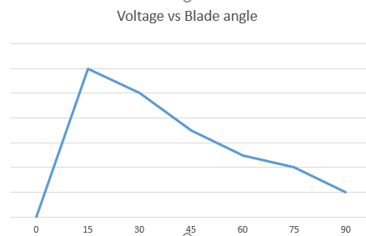

### Prac 2: Blade length

Students will measure voltage only. This is measured across the light globe. The output of the wind turbine depends on blade angle and multimeter connection.

Expected results

These results may surprise the students. Some will have predicted that the longer the blades, the greater the power output, because this provides the greatest surface area for the wind to push. Others will predict that shorter blades will deliver the most power, because they weigh less. (See the teacher background information)

As previously stated, some student groups may generate only three sets of results. Others may generate a larger number by testing different numbers of blades. The following tables show indicative results for three different length blades. These will be drawn on the same graph.

**Table of values for the graph of voltage against length of turbine blades,**

**for 4 blades set at 45⁰**

|  |  |  |  |
| --- | --- | --- | --- |
| Length of turbine blade(mm) | 75 | 100 | 150 |
| Voltage (V) | 0.85 | 0.72 | 0.29 |

**Table of values for the graph of voltage against length of turbine blades,**

**for 3 blades set at 45⁰**

|  |  |  |  |
| --- | --- | --- | --- |
| Length of turbine blade(mm) | 75 | 100 | 150 |
| Voltage (V) | 0.75 | 0.60 | 0.23 |

**Table of values for the graph of voltage against length of turbine blades,**

**for 2 blades set at 45⁰**

|  |  |  |  |
| --- | --- | --- | --- |
| Length of turbine blade  (mm) | 75 | 100 | 150 |
| Voltage (V) | 0.60 | 0.30 | 0.37 |

**Table of values for the graph of voltage against length of turbine blades,**

**for 12 blades set at 45⁰**

|  |  |  |  |
| --- | --- | --- | --- |
| **Length of turbine blade**  **(mm)** | **75** | **100** | **150** |
| **Voltage (V)** | **0.81** | **0.8** | **0.4** |

**Table of values for the graph of voltage against length of turbine blades,**

**for 6 blades set at 45⁰**

|  |  |  |  |
| --- | --- | --- | --- |
| Length of turbine blade (mm) | 75 | 100 | 150 |
| Voltage (V) | 0.50 | 0.72 | 0.57 |

#### Graph of Voltage against length of blades, for different numbers of blades

An alternative plot of the same data.

Discussion:

Although blade length theoretically is a continuous quantity, as is voltage, because the data was limited to three lengths the graph points have only been joined with broken lines. (The in-between values cannot be determined.)

Analysis requires a graph is constructed with all the data, including outlier data.

Colour coding (Red, yellow, blue) the plotted data points may reveal any patterns.

Recall the data points should not be joined as these are discrete quantities rather than continuous quantities.

### Prac 3: Number of blades

This experiment also builds up student understanding of how wind turbines work.

#### Background information for the teacher

The number of blades that delivers the delivers the greatest amount of power depends on other factors, such as their weight, surface area, angle, shape, and so on.

For the giant wind turbines on a wind farm, the weight of the turbine blades is a significant factor, this is why the turbines only have three blades. Small turbines may have more than three blades.

***Expected results***

These results are likely to surprise the students. Many will have predicted that the optimum number of blades is 3.

**Sample results* for 150 mm blades set at 45 ⁰**

|  |  |
| --- | --- |
| **Number of turbine blades** | **Voltage *V***  **(V)** |
| 12 | 0.40 |
| 6 | 0.57 |
| 4 | 0.29 |
| 3 | 0.23 |
| 2 | 0.37 |

**Corresponding table of values for the graph of voltage* against the number of turbine blades**

|  |  |  |  |  |  |
| --- | --- | --- | --- | --- | --- |
| **Number of turbine blades** | 2 | 3 | 4 | 6 | 12 |
| **Voltage**  **(V)** | 0.37 | 0.23 | 0.29 | 0.57 | 0.40 |

As indicated by the trends in the table, the voltage is indicative of power generated and the single voltage measurement serves to make a quick measurement of each wind turbine performance.

While it is not complete, this simplified approach provides a simple insight into turbine performance. Teachers are welcome to extend the activity using an ammeter, or additional multimeter, or to use a power sensor which simultaneously measures voltage and current to produce a real-time graph of power generated.

#### Sample graph of voltage against the number of blades

# Wind Farm Issues

## Wind Turbines and Birds

Students will conduct an online investigation into the impact of wind turbines on flying animals. Both birds and bats can be affected.

Students will examine the frequency of bird strikes and comment on whether safety measures are sufficient.

#### Advice for the classroom

This can be a very emotive issue for students who live near wind farms. Communities can be very divided on this issue. Responses can range from the kind of placards shown in the photograph in the student notes, to strong support of and lobbying for more wind farms. Outline the rules for critical thinking and emphasise the importance of basing arguments on objective scientific evidence. Also insist that the students show respect for those who have different views on this issue.

Suggested solutions to research questions

**1** For large commercial wind turbines, the towers are 60—90 m tall. Three blades, which are each about 20—40 m in length, rotate at about 10—22 revolutions per minute. Blade tip speeds are up to 320 kilometres per hour. (The largest wind turbine used at present delivers up to 6 MW. Its height is 198 m and its diameter is 126 m.)

**2** In the US it has been estimated that between 100 million and 1 billion birds die each year as a result of colliding with windows in residential and commercial buildings.

of colliding with windows in residential and commercial buildings.

**3** In the US it has been estimated that 50—100 million birds die each year as a result of colliding with cars and trucks.

**4** In the US it has been estimated that more than 100 million birds die each year as a result of being attacked by cats.

**5** In the US it has been estimated that 10 000—40 000 birds die each year as a result of colliding with wind turbines. Most of these have been in one particular region (Altamont Pass in California) and have been attributed to the topography, the location in relation to the local bird population and the major flight path of certain migratory birds, and the older, inefficient design of the wind turbines in this region.

**6** In the US in 2007, 4654 pedestrians were killed.

#### Suggested responses to reflection questions

**1—4** Student response

**5** Student response. Students may consider the impact of the lack of cars on employment, involvement in sports and recreation, ability to obtain medical help in the event of accidents or illness, and social contacts. They may consider the impact of the ban on cats on the emotional health and well-being of many people, especially isolated elderly.

**6** Student response. Students may raise points such as putting the issue into a wider perspective. What are the main dangers to birds?

**7** Student response. Students might consider the facts that there are far more wind turbines in the US. Australian wind turbines are of a newer design, so are likely to pose less danger than the more deadly older wind turbines in some regions of the US. Hence it is likely that there are far fewer bird deaths due to wind turbines here. Therefore the statement makes the problem sound far worse than it is.

**8** Student responses may include: Was the Minister motivated by election issues for his party in that region? Were the Minister and his party being criticised in the media for insufficient action on environmental issues at that time, or other bigger issues, so they needed to distract the public with an action that would gain public sympathy? What were the motives or those who lobbied the minister on this issue?

**9** Student response. Students might conclude that feral and domestic cats, vehicles, loss of habitat, the use of pesticides, and so on, are more likely to pose a danger to the birds and cause their extinction than wind turbines.

**10** Student response. Students might consider the fact that instead we could turn to nuclear power plants to meet our increasing energy demands, with their attendant risks, in order to reduce our greenhouse gas emissions.

## Wind Turbine Syndrome

Students will conduct an online investigation into the impact of wind turbines on people. Many people believe wind farms are ‘not a good thing’. This activity explores some of their reasons for their opinion.

#### Student Media Investigation

Search keywords: wind turbine syndrome fact fiction.

A brief search online will reveal hundreds of websites devoted to proving or disproving the existence of the Wind Turbine Syndrome (WTS). Care will need to be exercised in gaining a broad understanding of the topic. It is important to recognise WTS exists for those claiming the wind turbines have caused the condition.

Note: Students are invited to consider the evidence supporting the claims, not to comment on the merits of the issue.

# How Scientists Work

STELR aims to raise awareness of opportunities in STEM (science, technology, engineering and mathematics)-related careers in order to increase the number of students choosing science and engineering careers and to address the shortage of science and engineering graduates.

One of the reasons that students do not choose to pursue these careers is that they often do not understand what the career entails. For example, anecdotal evidence suggests that unless a student knows an engineer, they have little idea about engineering and are unlikely to consider it as a potential career.

Inspirational career profiles can help students in their career choices and career pathways.

Two career profiles are provided at the end of the student book with research questions for the students. They can use the profiles provided or source other career profiles from the web or they can interview someone they know.

An additional Careers in STEM worksheet can be downloaded from the STELR website: <https://stelr.org.au/stem-at-work/careers-in-stem/>

Additional career profiles are also supplied on the STELR website under the tabs: **STEM at Work** and **Women in STEM**.

# Optional Investigations

## Trying other variables

The prac activities in listed for students deal with the variables blade length, blade number and blade angle. Students might like to test other variables that could include:

* Wind speed (fan speed)
* Ridged face of blade to the wind instead of the smooth face
* Wind Angle
  + Position the fan so that it is not directly in front of the turbine
* Blade area
  + try different blade areas or make up three different configurations all with the same blade area. For example:  
    2 x red blades = 3 x blue blades = 4 x yellow blades = 60 cm3
* Use of obstacles on the path of the wind
  + Try using boxes to simulate buildings or trees near the turbine

These other variables could be generated by students through a brainstorming activity.

## Making the most cost effective wind turbine

Put an imaginary cost on the three different wind turbine blades. Give each group the same ‘budget’ and ‘sell’ the blades to the students.

Have them calculate the voltage per dollar spent and work out the most cost effective turbine blade configuration.

## Build your own wind turbine blades.

In this activity, students explore different blade profiles. By choosing different blade profiles, the performance can be enhanced.

A blade profile is taken as a cross-section across the blade.

The blade can be considered as a wing, the aerodynamic behaviour is very similar to the behaviour of the wing of an aeroplane.

Blade profiles suitable for 3D printing have been provided by STELR. A ‘blank’ with the appropriate hub stalk is available which allows students to design their own blade.

Factors to be considered:

* Length of blade
* Width of blade
* Weight of blade

Weight distribution along/across the blade

* Aerofoil profile – at the tip and the base and the transition along the length of the blade (usually a 90 ‘twist’)
* Zero (or minimal) air resistance offered by the hub
* Maximum energy transfer at the blade tip

## Wind blade specifications

|  |  |  |  |
| --- | --- | --- | --- |
| Blade | Length  cm | Area  cm2 | Mass  g |
| Yellow | 7.5 | 15 | 3.3 |
| Blue | 10 | 20 | 4.3 |
| Red | 15 | 30 | 6.3 |

A detailed blade drawing has been provided an the next page, to allow blade re-design suitable for 3D printing.

Contact the STELR office if you would like the .stl file for the red wind vane.

Macintosh HD:Users:gary:Dropbox:STELR:VANE 30sq cm.pdf

# Appendices

## Wind Energy Module Pre- and Post-test

The Pre- and Post-test multiple choice questions are essentiality the same except for question 11. The pre-test can be used to gauge student’s level of knowledge before the unit of work and also to identify any areas where there are misunderstandings. By doing a similar test at the end of the unit, students can see how they have progressed.

These tests are also available on the STELR Wind Energy USB ($10 from the STELR office)

What I currently know about Wind Energy.

### Question 1

When the wind blows, the air movement is caused by:

A the movement of the Earth

B the storms over the ocean

C day and night changes of sunlight

D local heating and cooling of the earth

E I don’t understand the question or I am not sure

### Question 2

Land and sea breezes are examples of:

A warm air and cool air moving

B convection cell circulation of air

C warm air rising

D oceans are cooler than land

E I don’t understand the question or I am not sure

### Question 3

Windmills and wind turbines move because:

A warm air rises against the blades

B convection currents push air onto the blades

C moving air pushes on the blade, slowing the air

D moving air going around the blades pulls them along

E I don’t understand the question or I am not sure

### Question 4

The kinetic energy of the wind is transferred to the wind turbine blade

A and is changed to potential energy when it hits the wind turbine blade

B and the blade gains all the kinetic energy

C and the wind loses all its kinetic energy

D when the wind collides with the blade and the wind loses kinetic energy

E I don’t understand the question or I am not sure

### Question 5

Wind mills and wind turbines have different size blades because:

A different wind speeds transfer amounts of kinetic energy dependent on blade speed

B different purposes require different designs

C different materials were available to build the windmill or wind turbine

D all of the above

E I don’t understand the question or I am not sure

### Question 6

The wind is blowing, but the wind turbine is not moving, reasons for this are:

A the wind is too strong or is too weak for the size of the wind turbine

B maintenance on the turbine requires a lockdown

C bird migrations are taking place this week

D all of the above

E I don’t understand the question or I am not sure

### Question 7

Wind energy is considered renewable because:

A wind turbines can be easily replaced

B no carbon dioxide or water vapour is produced during operation

C no waste heat energy is produced

D there is a continuing supply of wind energy

E I don’t understand the question or I am not sure

### Question 8

Which answer best completes this sentence correctly?

A flow chart that shows the energy transformation occurring in a wind turbine is best represented by:

A heat energy → electrical energy

B gravitational potential energy → electrical energy

C solar energy → electrical energy

D kinetic energy → electrical energy

E I don’t understand the question or I am not sure

### Question

Which answer best completes this sentence correctly?

Wind turbines do not contribute to the enhanced greenhouse effect while they are being used because:

A wind turbines produce only a minimal amount of waste heat energy.

B wind turbines do not produce any carbon dioxide gas.

C wind turbines are very efficient.

D wind turbines do not damage the ozone layer.

E I don’t understand the question or I am not sure

### Question 10

A solar panel is used to deliver electrical energy to a lamp. Which diagram shows the correct way of connecting a voltmeter to measure the voltage across the lamp?

|  |  |  |  |
| --- | --- | --- | --- |
| A | B | C | D |
| test1 | test2 | test3 | **test4** |

E I don’t understand the question or I am not sure

### Question 11 (Pre-test)

If an electric heater supplies 200 joules of heat energy to a cup of water, but only 150 joules is actually absorbed by the water, the remainder is ‘wasted’ by heating the cup and the room, the percentage energy efficiency of this process is said to be:

A 100%

B 75%

C 50%

D 25%

E I don’t understand the question or I am not sure

### Question 11 (Post-test)

When you were investigating factors affecting model wind turbine performance, the variables tested were blade length, number of blades and blade angle. The indicator of performance was:

A blade speed

B current generated

C voltage generated

D power generated

E I don’t understand the question or I am not sure

**Short Answer Questions (Pre-Test)**

### Question 1

There are two wind turbines of different designs. One has a small number of large blades, the other has a large number of small blades.

Predict which turbine will be the most efficient.

ie. Which turbine will produce the most electricity?

Explain your answer, use a drawing if necessary.

### Question 2

How would you test which is the best way to build a wind turbine? What are the main effects on performance? Explain your answer, use a drawing if necessary.

**Short Answer Questions (Post-Test)**

### Question 1

There are several ways to design a wind turbine. Explain how you would design a wind turbine and whether you would choose a small number of large blades, or a large number of small blades.

Explain which turbine will be the most efficient.

ie. Which turbine will produce the most electricity?

Explain your answer, use a drawing if necessary.

### Question 2

How would you prove your wind turbine was effective? What are the main effects on performance? Explain your answer, use a drawing if necessary.

## Post-test answers.

### Question 1

When the wind blows, the air movement is caused by:

A the movement of the Earth

B the storms over the ocean

C day and night changes of sunlight

D local heating and cooling of the Earth

E I don’t understand the question or I am not sure

### Question 2

Land and sea breezes are examples of:

A warm air and cool air moving

B convection cell circulation of air

C warm air rising

D oceans are cooler than land

E I don’t understand the question or I am not sure

### Question 3

Windmills and wind turbines move because:

A warm air rises against the blades

B convection currents push air onto the blades

C moving air pushes on the blade, slowing the air

D moving air going around the blades, pulls them along

E I don’t understand the question or I am not sure

### Question 4

The kinetic energy of the wind is transferred to the wind turbine blade

A and is changed to potential energy when it hits the wind turbine blade

B and the blade gains all the kinetic energy

C and the wind loses all its kinetic energy

D when the wind collides with the blade and the wind loses kinetic energy

E I don’t understand the question or I am not sure

### Question 5

Wind mills and wind turbines have different size blades because:

A different wind speeds transfer amounts of kinetic energy dependent on blade speed

B different purposes require different designs

C different materials were available to build the windmill or wind turbine

D all of the above

E I don’t understand the question or I am not sure

### Question 6

Large commercial wind turbines usually have

A two blades

B three blades

C four blades

D the number of blades depends on location and amount of wind

E I don’t understand the question or I am not sure

### Question 7

Wind energy is considered renewable because:

A wind turbines can be easily replaced

B no carbon dioxide or water vapour is produced during operation

C no waste heat energy is produced

D there is a continuing supply of wind energy

E I don’t understand the question or I am not sure

### Question 8

Which answer best completes this sentence correctly?

A flow chart that shows the energy transformation occurring in a wind turbine is best represented by:

A heat energy → electrical energy + sound energy

B gravitational potential energy → electrical energy + heat energy + sound energy

C solar energy → electrical energy + heat energy + sound energy

D kinetic energy → electrical energy + heat energy + sound energy

E I don’t understand the question or I am not sure

### Question 9

Which answer best completes this sentence correctly? Wind turbines do not contribute to the enhanced greenhouse effect while they are being used because:

A wind turbines produce only a minimal amount of waste heat energy.

B wind turbines do not produce any carbon dioxide gas.

C wind turbines are very efficient.

D wind turbines do not damage the ozone layer.

E I don’t understand the question or I am not sure

### Question 10

A solar panel is used to deliver electrical energy to a lamp. Which diagram shows the correct way of connecting a voltmeter to measure the voltage across the lamp?

|  |  |  |  |
| --- | --- | --- | --- |
| A | B | C | D |
| test1 | test2 | test3 | **test4** |

E I don’t understand the question or I am not sure

### Question 11

When you were investigating factors affecting model wind turbine performance, the variables tested were blade length, number of blades and blade angle. The indicator of performance was:

A blade speed

B current generated

C voltage generated

D power generated

E I don’t understand the question or I am not sure

## Rubrics

#### ASSESSMENT RUBRIC - SCIENCE INQUIRY SKILLS

**STUDENT NAME: _______________________________________ CLASS: __________**

|  |  |  |  |  |
| --- | --- | --- | --- | --- |
| **Science inquiry skill** | **Undeveloped** | **Developing** | **Proficient** | **Exemplary** |
| **Designing an experiment** | The student can:  • Develop a testable hypothesis with assistance.  • Show little understanding of the variables operating  • With assistance can design simple fair tests and select equipment suited to the purpose. | The student can:  • Develop a testable hypothesis with assistance.  • Identify some variables with assistance, and  • Design simple fair tests and select equipment suited to the purpose. | The student can:  • Develop a testable hypothesis.  • Identify a number of variables and, with assistance, design an experimental investigation a procedure in which these are tested one at a time and repeat trials are conducted.  • Select equipment suited to the purpose.  • Suggest some ways to reduce risk in the investigation. | The student can:  • Develop a testable hypothesis based on prior observations and/or secondary sources.  • Design an experimental investigation, including using repeat trials and replicates, independently identifying and controlling variables and selecting equipment suited to the purpose.  • Suggest a number of ways to reduce risk in the investigation that show insight into the specific risks involved. |
| **Collection of data** | The student can:  • With assistance, collect data in a consistent and ethical manner, including using ICT where possible.  • Use equipment and materials safely, with assistance and advice. | The student can:  • With assistance, collect data in a consistent and ethical manner, including using ICT where possible.  • Use a wide range of equipment and materials safely. | The student can:  • Collect data in a consistent and ethical manner, including using ICT where possible.  • Use a wide range of equipment and materials safely and show consideration of the safety of others. | The student can:  • Collect data in a consistent, efficient and ethical manner, including using ICT where possible.  • Use a wide range of equipment and materials safely and manage the working environment for the safety of self and others. |
| **Recording and processing data** | The student can:  • Record some data in provided tables with accuracy.  • With assistance, construct graphs with reasonable accuracy. | The student can:  • Record data in provided tables accurately.  • With assistance, construct graphs with accuracy.  • Use simple statistical tools to process and analyse data, with assistance. | The student can:  • Select and design tables and graphs for the recording and analysis of **some** data.  • Record data in provided tables accurately.  • Construct graphs with accuracy.  • Use simple statistical tools to process and analyse data with accuracy. | The student can:  • Select and design tables and graphs for the recording and analysis of data.  • Record data efficiently and accurately.  • Construct graphs with accuracy  • Use simple statistical tools to process and analyse data with accuracy. |
| **Analysis and evaluation of data** | The student can:  • Draw conclusions from observations, evidence and data, and relate this to hypotheses, with assistance.  • With assistance, identify sources of error in the investigation method. | The student can:  • Draw conclusions from observations, evidence and data, and relate this to hypotheses and scientific concepts, with assistance.  • With assistance, Identify sources of error in the investigation method. | The student can:  • Draw conclusions from observations, evidence and data, and relate this to hypotheses and scientific concepts.  • Identify sources of error in the investigation method and suggest specific improvements that would reduce error. | The student can:  • Draw conclusions or explain interactions from observations, evidence and data, and relate this to hypotheses and scientific concepts.  • Identify sources of error in the investigation method and suggest specific improvements that would reduce error.  •Critique reports of investigations noting any flaws in design or inconsistencies of data. |
| **Communication of findings** | The student can:  • With assistance, communicate findings using scientific language and meaningful representations and make evidence-based arguments. | The student can:  • Communicate findings using scientific language with a fair degree of accuracy and using some meaningful representations.  • With assistance, make evidence-based arguments. | The student can:  • Communicate findings using scientific language with a good degree of accuracy and fluency, and using meaningful representations.  • Make evidence-based arguments. | The student can:  • Communicate findings using scientific language with a high degree of fluency and accuracy, and using meaningful representations and make evidence-based arguments. |

|  |
| --- |
| **Overall evaluation with comment/evidence:** |

Teacher’s signature: _____________________________________ ***Date: / /***

#### ASSESSMENT RUBRIC – GROUP PROJECTS

**STUDENT NAME: _______________________________________ CLASS: __________**

**NAMES OF GROUP MEMBERS: _____________________________________________**

**RENEWABLE ENERGY RESOURCE INVESTIGATED: ____________________________**

|  |  |  |  |  |
| --- | --- | --- | --- | --- |
| **Aspect** | **Undeveloped** | **Developing** | **Proficient** | **Exemplary** |
| **The science and technology behind the energy resource** | The group:  • Showed little evidence of suitable research.  • Displayed a limited understanding of the science and technology behind their chosen renewable energy resource. | The group:  • Researched this aspect to some degree.  • Displayed some understanding of the science and technology behind their chosen renewable energy resource. | The group :  • Researched this aspect to a reasonable depth.  •Displayed a good understanding of the science and technology behind their chosen renewable energy resource and communicated this with clarity. | The group:  • Researched this aspect in depth.  • Displayed a thorough understanding of the science and technology behind their chosen renewable energy resource and communicated this in a logical way with clarity and fluency, including an explanation of unfamiliar terms. |
| **The benefits and problems associated with the energy resource, and community views** | The group:  • Showed little evidence of suitable research.  • Presented conclusions that were based on insufficient evidence and analysis. | The group :  • Researched this aspect to some degree.  • Applied some critical thinking skills to draw their conclusions. | The group:  • Researched this aspect to a reasonable depth.  • Presented some evidence-based arguments and applied some critical thinking skills to draw their conclusions. | The group :  • Researched this aspect in depth. • Presented evidence-based arguments and applied well-developed critical thinking skills to draw their conclusions. |
| **The uses of the energy resource and its likely future** | The group:  • Showed little evidence of suitable research.  • Presented conclusions that were based on insufficient evidence and analysis. | The group :  • Researched this aspect to some degree.  • Applied some critical thinking skills to draw their conclusions. | The group:  • Researched this aspect to a reasonable depth.  • Presented some evidence-based arguments and applied some critical thinking skills to draw their conclusions. | The group :  • Researched this aspect in depth. • Presented evidence-based arguments and applied well-developed critical thinking skills to draw their conclusions. |
| **Presentation of findings** | The group:  • Presented some findings using a small number of visual aids.  • Showed some understanding of their subject.  • Were sometimes audible and sometimes established eye contact with their audience. | The group :  • Showed some evidence of preparing for their presentation.  • Presented their findings using some visual aids.  • Showed some understanding of their subject and were able to answer some questions.  • Were generally audible and generally established eye contact with their audience. | The group:  • Prepared well for their presentation.  • Presented their findings in an engaging way, making use of a range of visual and other communication aids.  • Showed good understanding of their subject and were able to answer questions clearly.  • Were audible, established eye contact with their audience and involved their audience. | The group:  • Prepared thoroughly for their presentation.  • Presented their findings in a creative and engaging way, making full use of a range of visual and other communication aids.  • Showed a thorough understanding of their subject, answering questions confidently.  • Were clearly audible, established good eye contact with their audience and involved their audience to a great degree. |
| **Student contribution to group** | The student:  • Co-operated with the group most of the time.  • Contributed to most aspects of the project. | The student :  • Co-operated well with the group.  • Contributed to all aspects of the project. | The student:  • Co-operated very well with the group and showed well-developed time management skills.  • Contributed well to all aspects of the project. | The student:  • Co-operated well with the group and showed initiative and well-developed leadership and time management skills.  • Contributed fully to all aspects of the project. |

Comment: ______________________________________________________________________________

|  |
| --- |
| ______________________________________________________________________________  ______________________________________________________________________________  ______________________________________________________________________________  ______________________________________________________________________________  ______________________________________________________________________________ |

Teacher’s signature: _____________________________________ ***Date: / /***

#### ASSESSMENT RUBRIC – Peer Assessment PROJECTS

**STUDENT NAME: _______________________________________ CLASS: __________**

**NAMES OF GROUP MEMBER: _______________________________________________**

**RENEWABLE ENERGY RESOURCE INVESTIGATED: ____________________________**

|  |  |  |  |  |
| --- | --- | --- | --- | --- |
| **Criteria** | ***UNDEVELOPED*** | ***DEVELOPING*** | ***PROFICIENT*** | ***EXEMPLARY*** |
| **Clarity of presentation of the activity**  Voice Projection Appropriate Vocabulary  Engagement with the audience. Eye contact  Response to audience’ questions, feedback | * Voice is not projected well * Poor eye contact with audience * Audience not engaged * No enthusiasm for subject * Did not present in a timely way | * Voice is decipherable * Everyday vocabulary * Little evidence of attempts to include all the audience * Fair eye contact with audience * Presenter tries to respond to audience * Time not well planned | * Commentary is satisfactory * Vocabulary includes science terminology * Good eye contact * Some audience engagement. * presenters respond well to audience’ questions * Time well used | * Voice is projected well * Confident use of scientific vocabulary * Good choice of presentation tools/resources * Good eye contact * Audience engaged. * Presenters respond well to audience’ questions * Challenges audience – promotes thinking |
| **Explanation of renewable energy – potential use, human aspects, technical aspect, Demonstration of knowledge** | * Superficial treatment- using everyday knowledge only * No real new knowledge * No discussion of the human aspects * No /little discussion of the technical aspects | * + - * Content – is relevant * Explanation not strong, lacking confidence * Little reference to the human aspects   + - * Little reference to the technical aspects | * + - * Content – very relevant to energy       * Good explanation       * Demonstrated a sound understanding of renewable energy       * Most social and technical aspects are discussed | * + - * Content –describes clearly renewable energy-       * Explores all limitations and advantages of Renewable energy       * Discussion of the social and technical aspects that impact on the use of the renewable energy |
| **Evidence of scientific process – inquiry** | * No clear link between data and conclusions | * + - * Some evidence of an inquiry approach – with some data linked to conclusions. | * + - * Good evidence of data collected and linked to conclusion. | * + - * Evidence of inquiry, planning, and carrying out experiment, processing information etc Includes error analysis, discussion of errors. |

Comment: _________________________________________________________________________

|  |
| --- |
| ______________________________________________________________________________  ______________________________________________________________________________  ______________________________________________________________________________  ______________________________________________________________________________  ______________________________________________________________________________ |

Teacher’s signature: _____________________________________ ***Date: / /***

## Investigation Planner

|  |  |
| --- | --- |
| What you are investigating | |
| What are you going to investigate? | What do you think will happen? Explain why. |
| What is your hypothesis? | What is the aim of your investigation? |
| Designing your experiment | |
| What variables might affect the outcome of your investigation? | Which variable(s) will you test? |
| How will you make your tests fair? | What observations and measurements will you need to take? |
| How will you ensure that your measurements are reliable? | What calculations (if any) will you need to perform? |
| What risks might be involved in conducting your investigation? Hence, what safety precautions do you plan to take? | What materials, including equipment will you need? |
| Your results | |
| How will you record your observations and measurements?  Design any suitable tables and draw them up ready in your journal.  Can you use symbols and a key to avoid repeated writing of your observations? If so, have these ready under the appropriate tables. | What graphs can you draw and what spreadsheets can you design to display your results and to enable you to identify any patterns and relationships? |
| Conducting your investigation | |
| Once your teacher has approved your plans and supplied the materials, conduct your investigation.  Record how you performed the investigation, in your journal. Be sure to include any modifications you made to your plans and the reasons for them. | |
| Analysing your results: your conclusions | |
| Examine your results. Use them to answer your aim. | From your conclusions, were your predictions and hypothesis correct? Does your hypothesis need to be modified? Discuss. |
| Evaluating the investigation | |
| How reliable do you think your results were? Discuss. | How could you modify your procedure to make your results more reliable? |
| If you were given the opportunity, what further investigation would you carry out to build on what you learned from this investigation? | |

